Summary of Daily Pelican Observations at McNary Dam Juvenile Outfall.

Attached is a summary of the number of American white pelicans observed in the juvenile fish outfall zone (JFOF; Figure 1) at McNary Dam, summarized by week. Numbers of pelicans in the JFOF typically peak in July or early August (Table 1). The 10-year average number peaked at over 200 birds in early July (Figure 2). Pelicans observed in the JFOF zone are typically about 15 to 20% of the total number of pelicans observed at the dam during any given week (Table 2 and Figure 3).

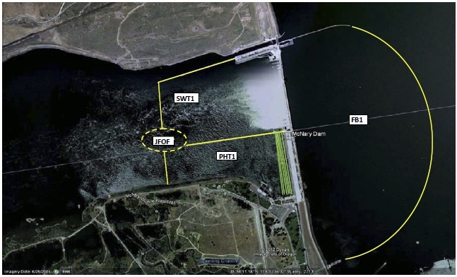

Figure 1. The four bird observation zones in the forebay (FB1), spillway tailrace (SWT1), powerhouse tailrace (PHT1) and juvenile fish outfall (JFOF) at McNary Dam.

Table 1. Counts and 10 year average number of American white pelicans observed in the juvenile fish outfall (JFOF) zone at McNary Dam, summarized by week, 2005 to 2016.



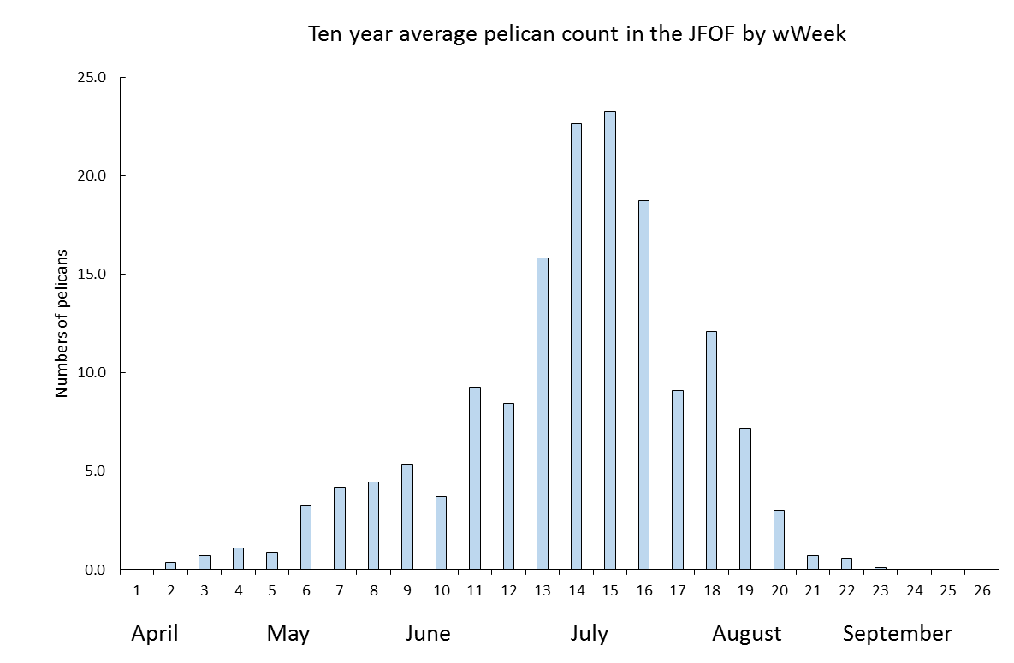

Figure 2. The 10-year weekly mean number of American white pelicans observes in the juvenile fish outfall (JFOF) zone during the period 2007-16.

Table 2. The weekly and 10-year average percent of pelicans observed at McNary Dam that were observed in the juvenile fish outfall (JFOF) zone; 2005-2016.



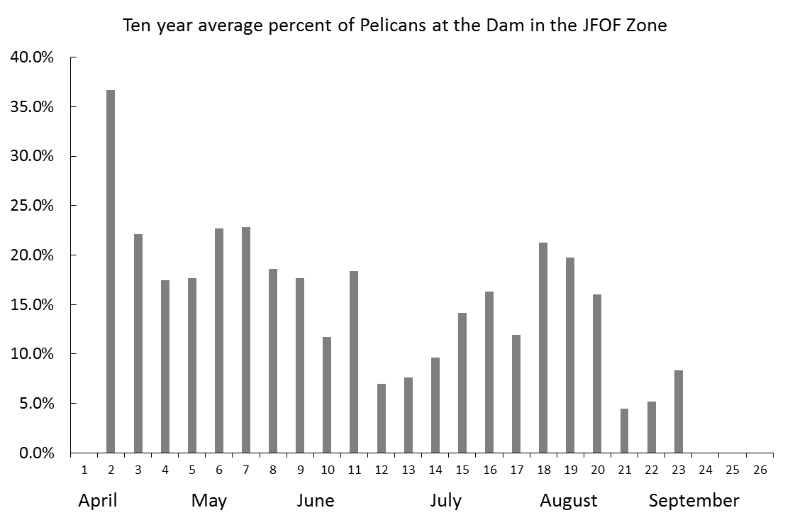

Figure 3. The 10-year weekly mean percent of American white pelicans observes in the juvenile fish outfall (JFOF) zone at McNary Dam during the period 2007-16.